**User Guide for Jensen Decors**



|  |  |  |
| --- | --- | --- |
| **SUPERVISOR** | **Miss Samia Mehreen** | |
| **BATCH CODE** | **2501C01** | |
| **GROUP** | **A** | |
| **SERIAL NO** | **ENROLLMENT NUMBER** | **STUDENT NAME** |
| **1** | Student1639612 | Amin ul haq |
| **2** | Student1636429 | MUHAMMAD MAAZ TAHIR |
| **3** | Student1640454 | Shan Saeed |
| **4** | Student1635761 | Rayyan Habib |

**Project Overview:**

**Home Page:**

**Navbar:**

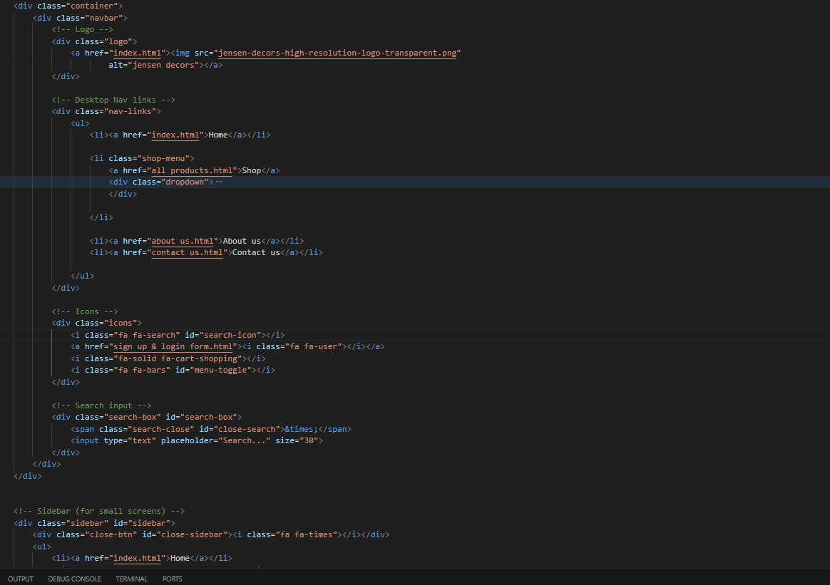



**Navbar Menu Catagories And Sub-catagories:**

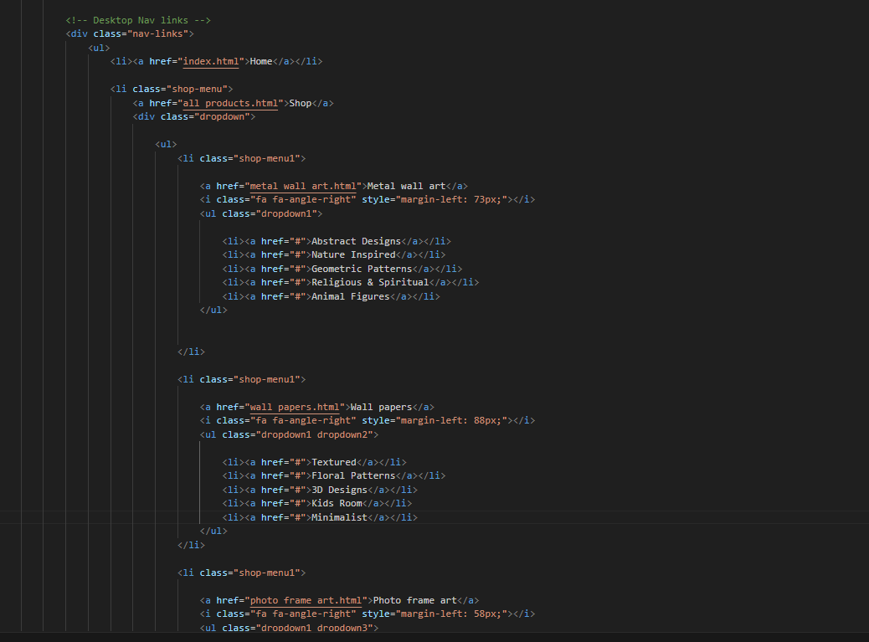

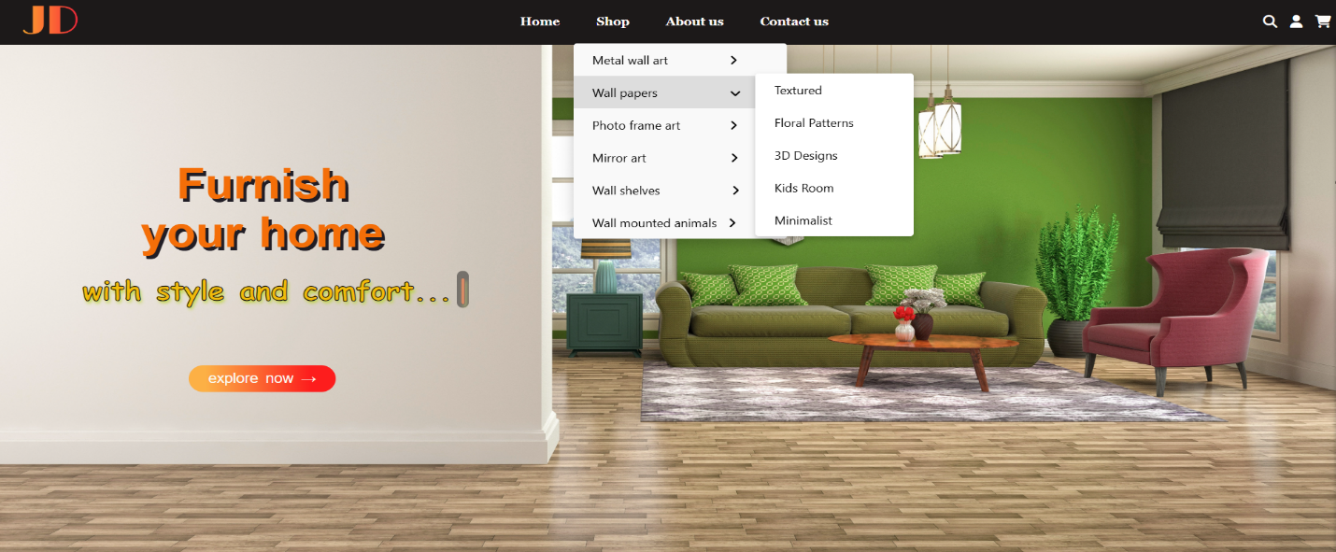

**Add Carousel :**

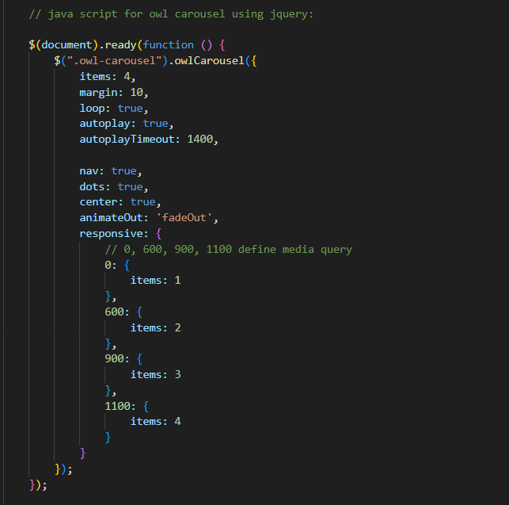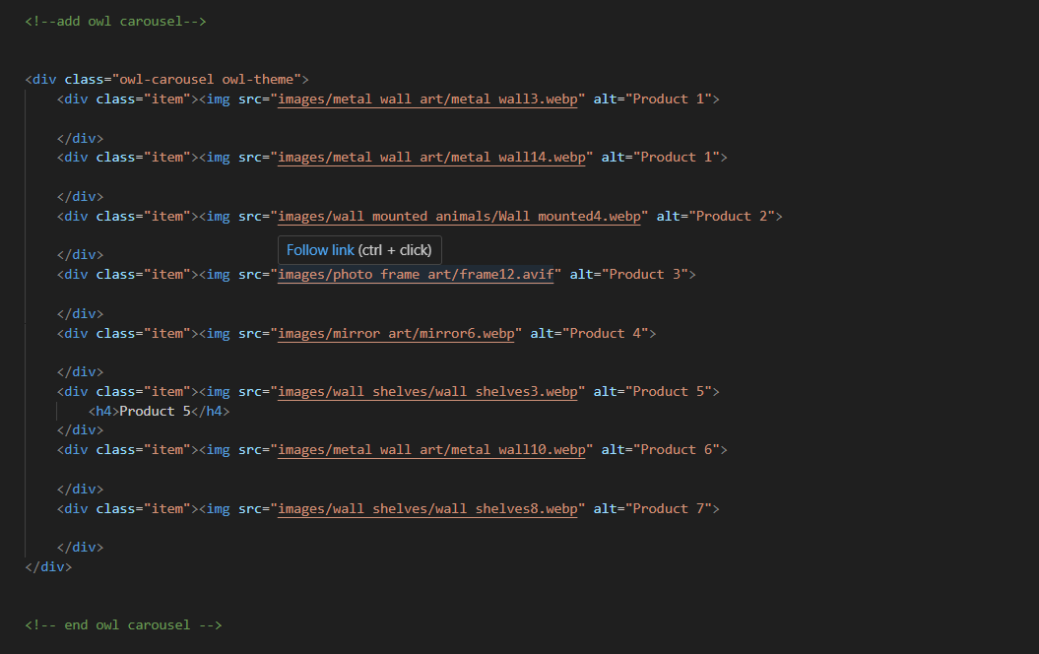

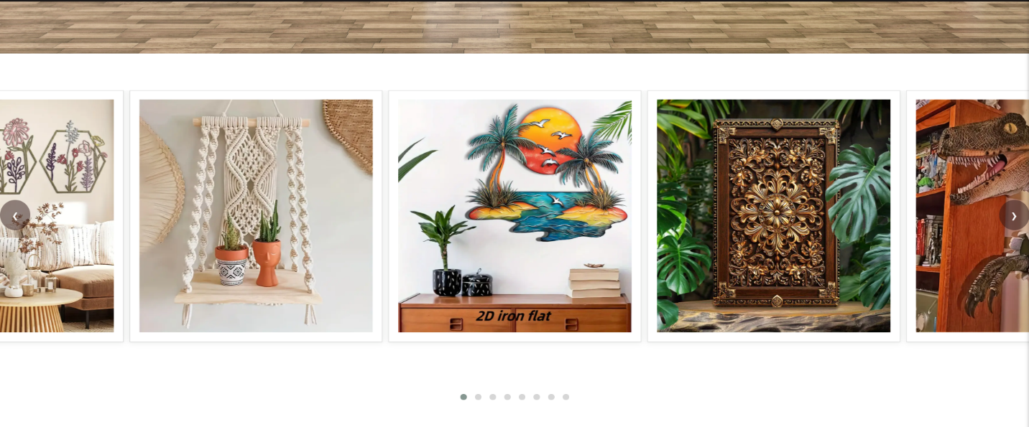

**Adding Some Products from All Categories :**

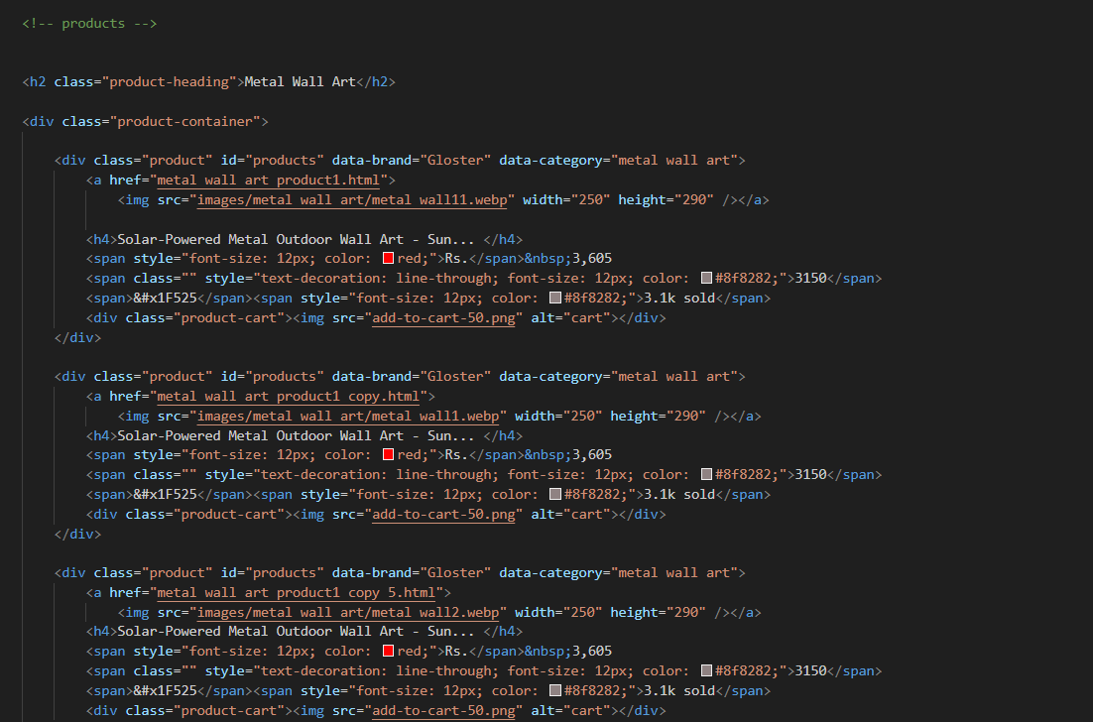

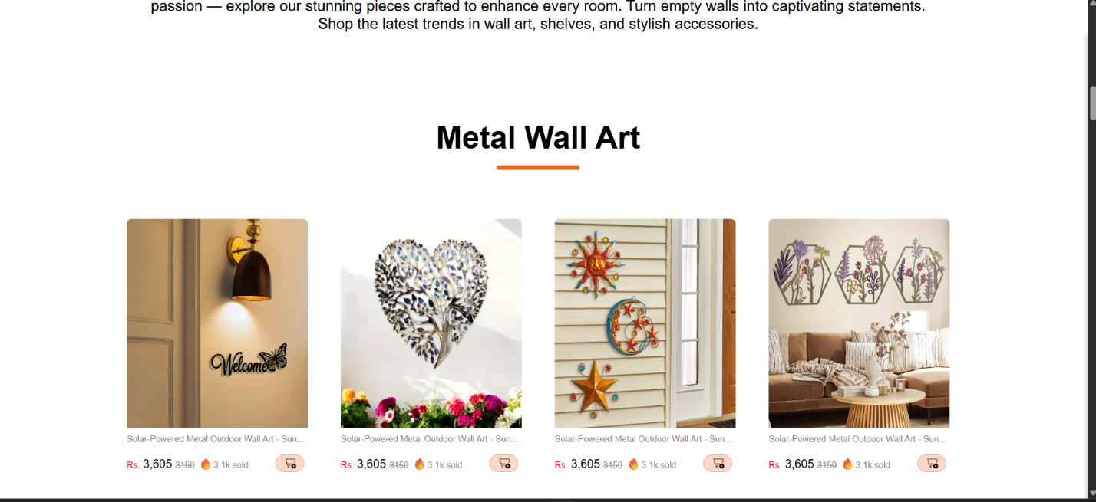

**Testimonials (Customer reviews):**

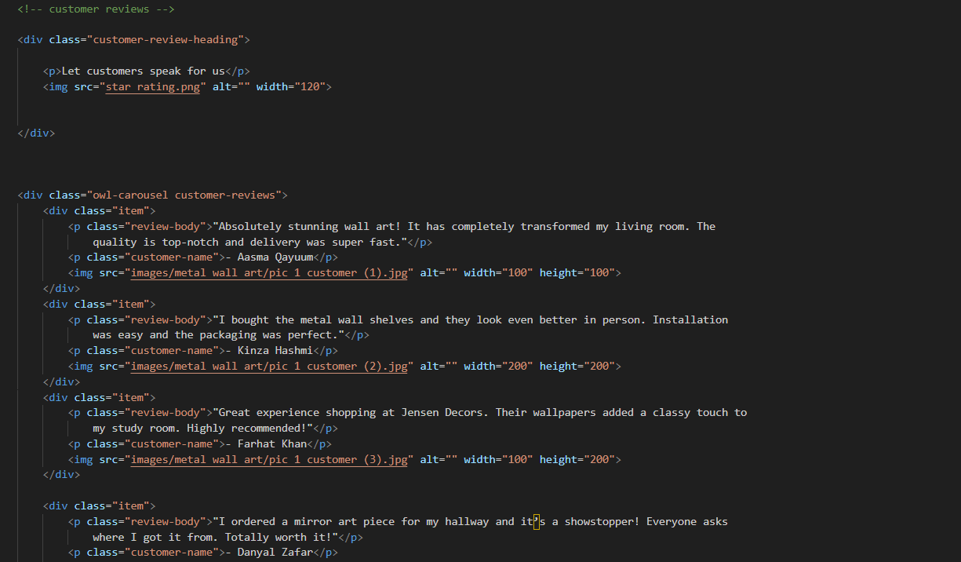

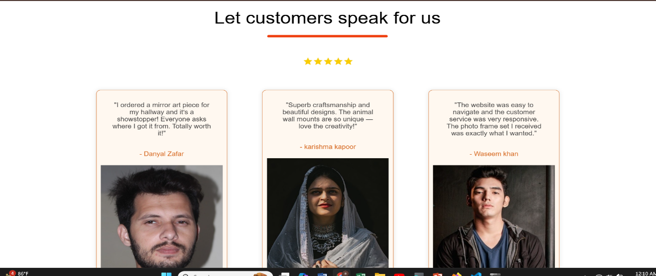

**Footer at the end:**

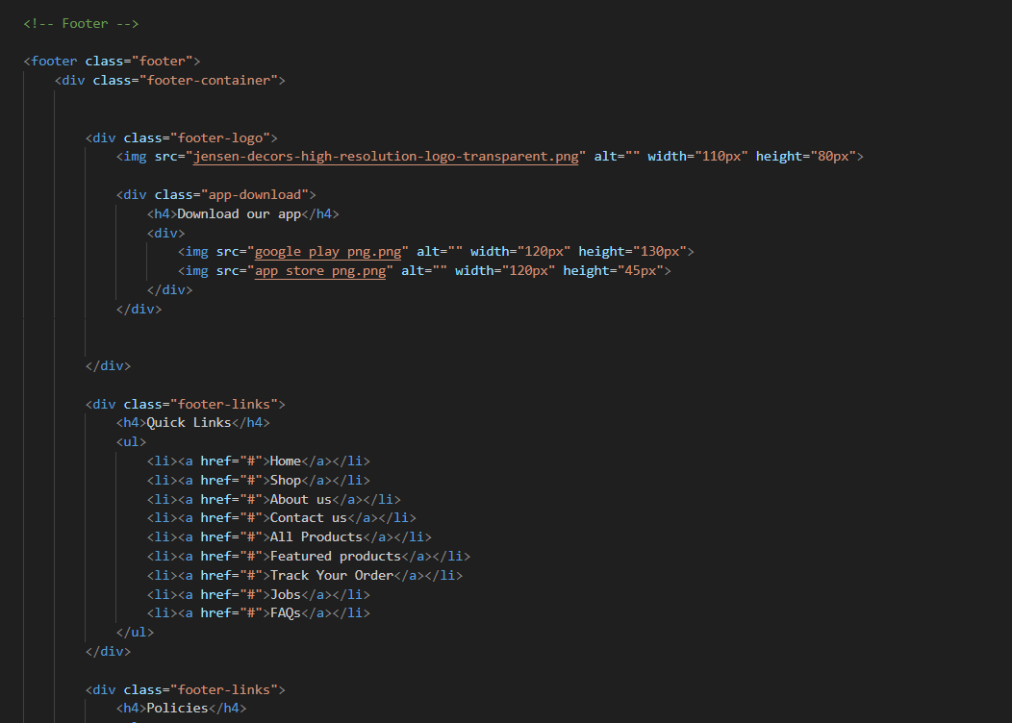

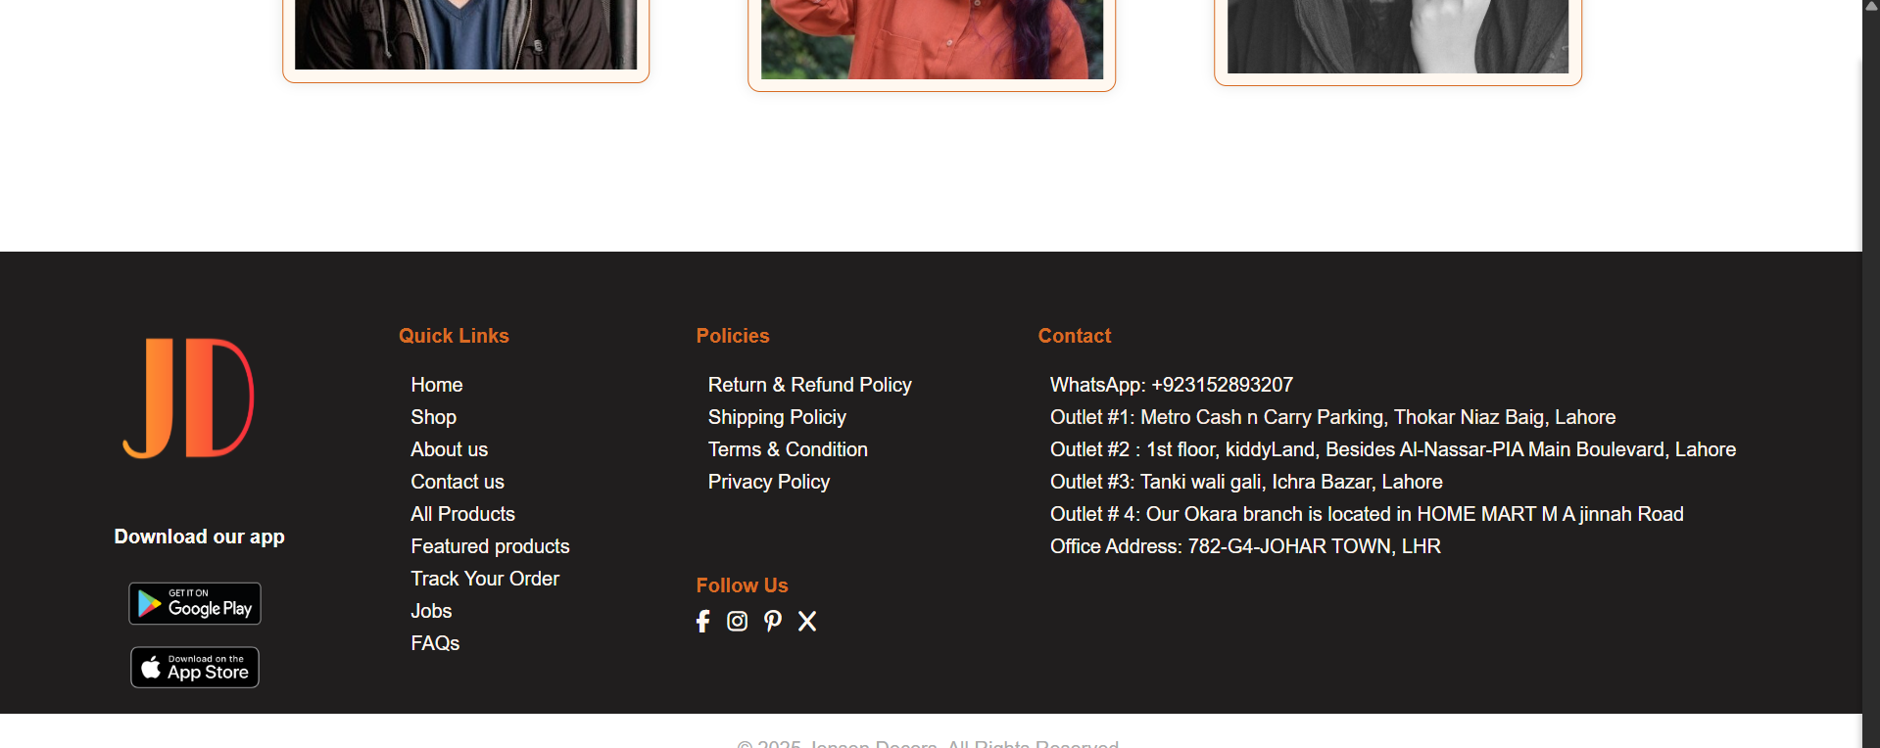

**Individual Categories Page for All Categories:**

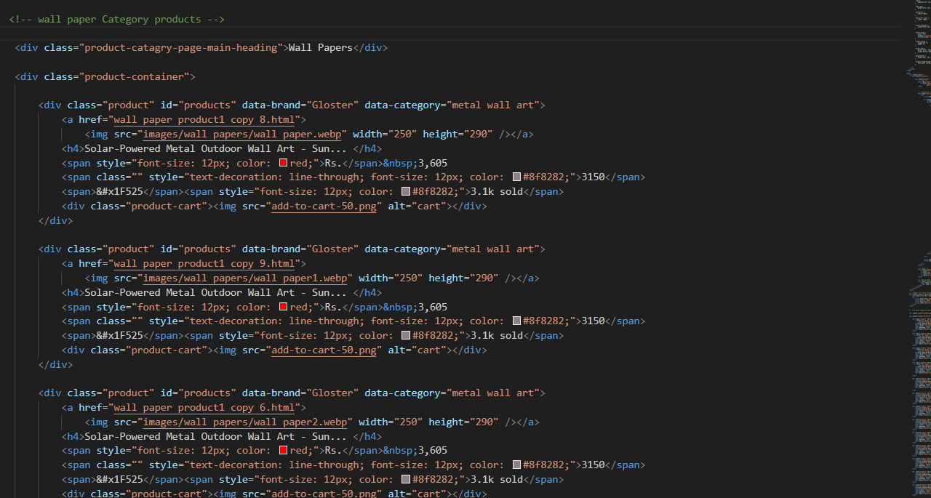

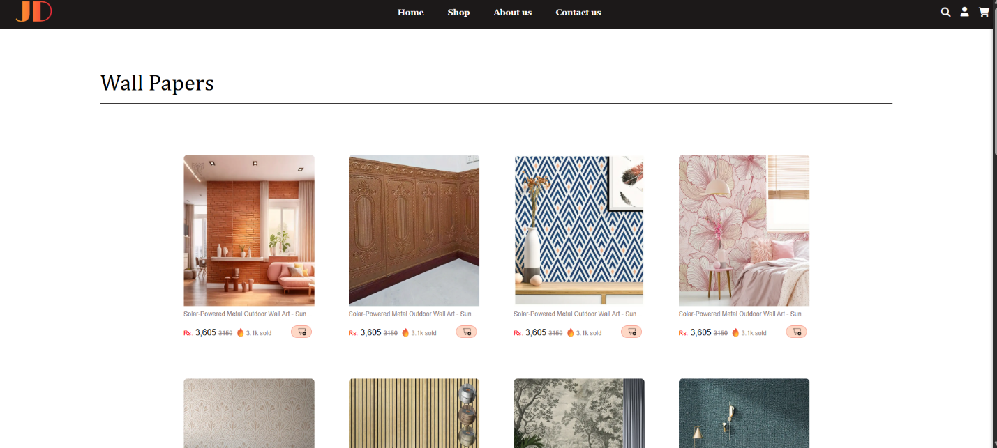

**About Us page:**

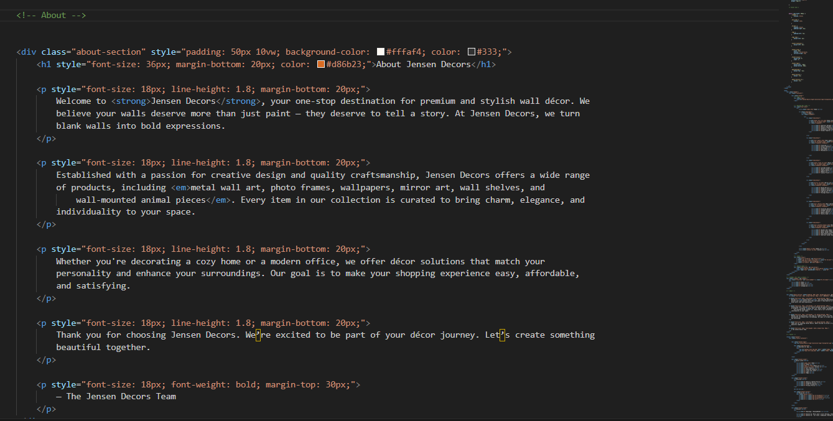

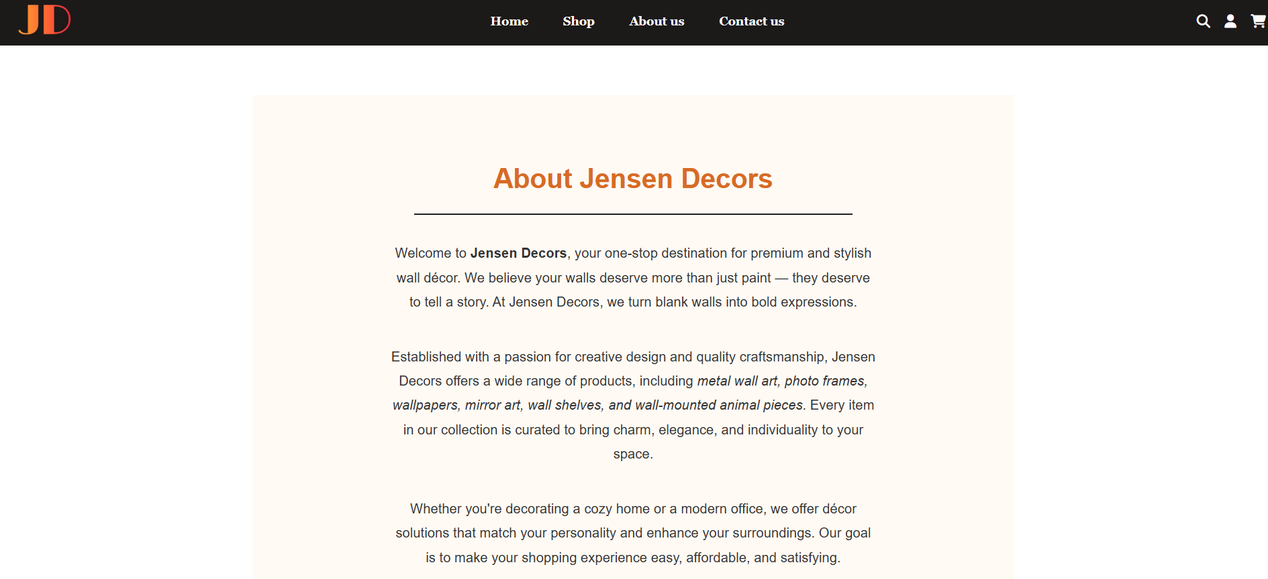

**Contact us page:**

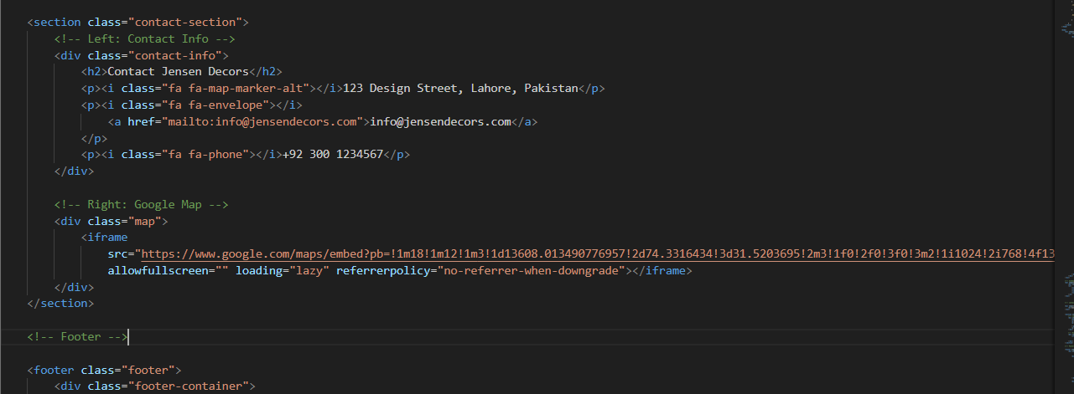

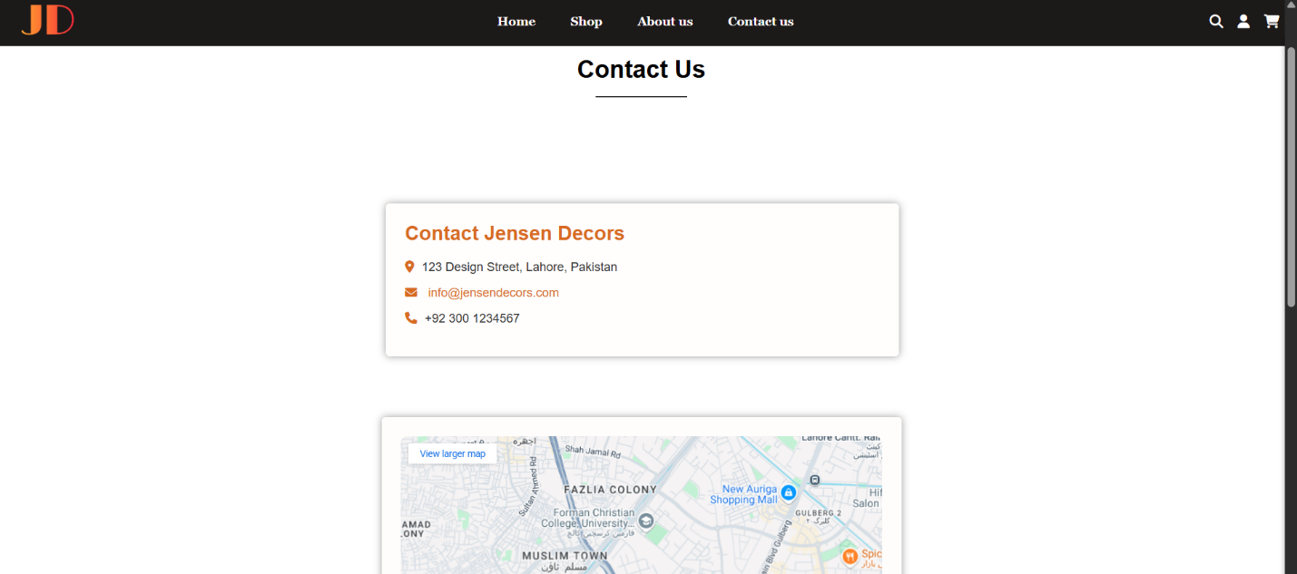

**Sign up or Login page:**

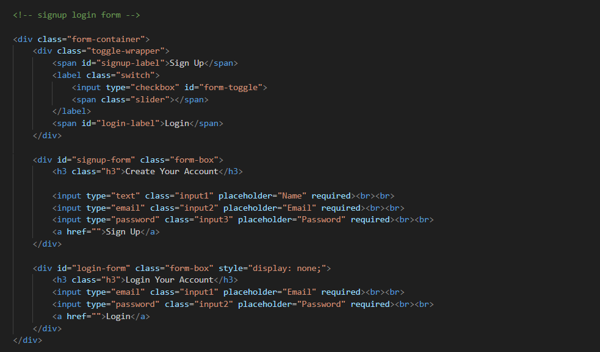

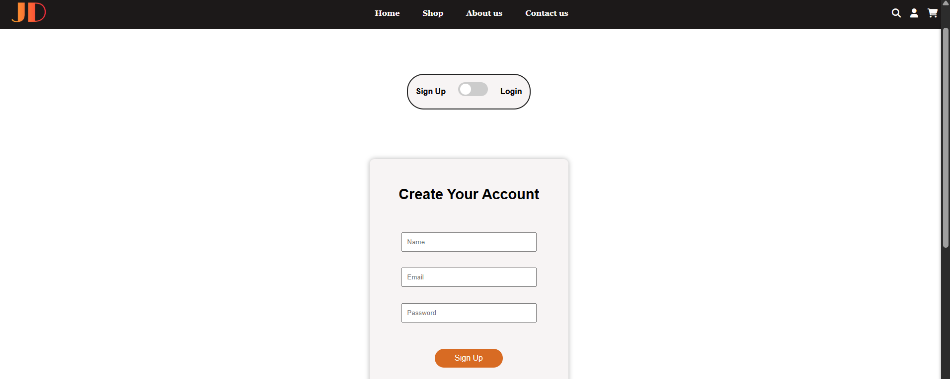

**Product Description Page:**

